CS7 – S02: GPU Offloading Crossover Point
BCSE412L Parallel Computing · Fall Semester 2026–27
Ananya Jain Registration No.: 23BCE0593

Abstract
This study measures when CUDA GPU offloading becomes faster than CPU execution for vector addition, tiled matrix multiplication and 3×3 image blur. On a Kaggle Tesla T4 with a four-logical-CPU Xeon environment, the end-to-end GPU crossover against CPU OpenMP was first observed at matrix dimension 91 and blur width 128. Vector addition never crossed over up to 67,108,864 elements. The results show that transfer and launch costs can outweigh kernel speedup, while computation-heavy workloads can amortize those costs at larger sizes.

1. Introduction and Literature Survey
A GPU can accelerate parallel kernels, but practical benefit depends on transfer and launch overhead. NVIDIA recommends minimizing host–device transfers [1], while surveys and performance models explain why data movement can dominate end-to-end runtime [2–4]. Studies of Unified Memory and GPU-port validation also show that performance depends on workload and configuration [5, 6]. This study compares vector addition, tiled matrix multiplication and 3×3 image blur to identify when offloading becomes worthwhile.
Gap addressed. Existing work explains transfer costs and heterogeneous scheduling, but this case study directly compares three workload types while separating kernel time from end-to-end time to measure how the crossover changes with workload characteristics.

2. Problem, Research Question and Hypotheses
Problem. Determine the problem size at which GPU execution becomes faster than equivalent CPU execution after including host–device transfers and offloading overhead.
Research question. At what size does GPU offloading become beneficial, and how does the crossover depend on workload characteristics?
Hypotheses. H1: crossover differs by workload. H2: kernel-only timing shows GPU advantage earlier than end-to-end timing. H3: vector addition may not achieve an end-to-end GPU advantage because its arithmetic intensity is low.

3. Methodology and Experimental Design
Three workloads—vector addition, tiled matrix multiplication and 3×3 image blur—were implemented with CUDA and compared against CPU serial and OpenMP versions. The experiment ran on a Kaggle Tesla T4 with an Intel Xeon environment exposing four logical CPUs. Problem sizes increased geometrically by approximately √2, so the sweep samples small and large workloads without relying only on a linear size interval. Each sweep was repeated three times and medians are reported; GPU output was compared with CPU output to check correctness.
Experimental design. The independent variables were workload type and problem size; the implementation/device (CPU serial, CPU OpenMP or CUDA GPU) defined the comparison groups. The main dependent measures were CPU time, GPU kernel time, end-to-end time, transfer fraction and speedup. Hardware, compiler target, data type and workload definitions were held consistent within the run so that observed differences could primarily be attributed to workload size and execution path.
Repeated measurements and robust summary. Timing can vary because of cloud scheduling, device clocks and runtime noise. Three independent sweep trials were therefore collected and the median was used instead of the mean, reducing the influence of occasional slow runs. The reported spread is retained as a reminder that small differences near a crossover may not be meaningful.
Crossover definition. Speedup is CPU OpenMP time divided by GPU time, so values above 1 indicate a GPU win. The interpolated crossover estimates where speedup reaches 1 between adjacent sampled sizes; the first persistent measured win is the first tested size after which all larger tested sizes remain faster on the GPU. Reporting both distinguishes a model-based estimate from a directly observed threshold.
Component | Configuration
Hardware | NVIDIA Tesla T4 (15,360 MiB; sm_75); Intel Xeon @ 2.00 GHz; 4 logical CPUs
Software | Kaggle; CUDA Toolkit 12.8 (nvcc V12.8.93); Python 3.13.15; OpenMP
Workloads | Vector addition: 256–67,108,864 elements; matrix multiplication: n=8–2,048; image blur: width 16–8,192
Timing | CPU serial/OpenMP, H→D and D→H transfers, kernel, allocation/free and end-to-end time

End-to-end speedup = CPU OpenMP time / GPU end-to-end time. The interpolated crossover estimates where speedup reaches 1 between sampled sizes; the first measured win is the first sampled size after which GPU execution remains faster.
Table 1. Metrics and plots used in the experiment.
Metric / plot | Definition used | What it tells us
Problem size vs time | Problem size on x-axis; CPU serial, CPU OpenMP, GPU kernel and GPU end-to-end time on y-axis (ms, logarithmic scale where needed). | Identifies where GPU time curves fall below CPU curves and shows absolute cost.
Speedup vs size | CPU OpenMP time ÷ GPU kernel time, and CPU OpenMP time ÷ GPU end-to-end time. Reference line = 1×. | Above 1× means GPU is faster than the CPU baseline; the gap between kernel and end-to-end curves quantifies offload overhead.
Transfer fraction | (Host-to-device time + device-to-host time) ÷ GPU end-to-end time × 100%. | A high fraction indicates data movement dominates; it explains why a fast kernel may not yield an end-to-end win.
Crossover size | Interpolated crossing at speedup = 1, plus first persistent measured GPU win. | Separates an estimate between samples from a directly observed threshold.
Correctness error | Maximum relative error between CPU and GPU outputs. | Checks whether performance gains preserve numerical correctness.
Timing variability | Median run-to-run spread across the three sweep trials. | Indicates how confidently small performance differences should be interpreted.

This design supports a fair within-environment comparison, but it is not a universal hardware benchmark: only one GPU/CPU environment and three sweep trials were used, and the CPU and GPU implementations are representative rather than equally tuned library implementations.
Table 2. Summary of measured crossover results.
Workload | End-to-end crossover vs CPU OpenMP | Maximum speedup | Inference from results
Vector addition | No end-to-end crossover | 0.163× | Transfer fraction remains high; CPU is preferable for a standalone operation.
Matrix multiplication | n≈70 interpolated; n=91 first persistent win | 24.392× at n=2,048 | Compute grows rapidly with matrix size, amortizing offload costs.
Image blur | ≈107 px interpolated; 128 px first persistent win | 2.940× at width 2,048 | GPU wins only after larger inputs; transfer overhead remains significant.

4. Results and Graph-Based Inference
Workload | Kernel crossover (interpolated) | End-to-end crossover (interpolated) | First measured end-to-end win | Maximum end-to-end speedup
Vector addition | ≈90,813 elements | Not reached | None | 0.163×
Matrix multiplication | n≈35 | n≈70 | n=91 | 24.392× at n=2,048
Image blur | ≈37 px | ≈107 px | 128 px | 2.940× at width 2,048

Figure 1 shows the key contrast: vector addition’s kernel becomes faster, but its end-to-end speedup remains below 1. Its transfer fraction is high, so moving data costs more than the simple arithmetic saves. This supports H3.
Inference from the curve. The gap between kernel-only and end-to-end speedup means the GPU is not the bottleneck once the simple addition kernel is accelerated; data movement and offload overhead dominate. Increasing the vector length does not remove this penalty in the measured range. A practical implication is to prefer CPU execution for a standalone vector addition, or keep the vectors on the GPU when later operations can reuse them.
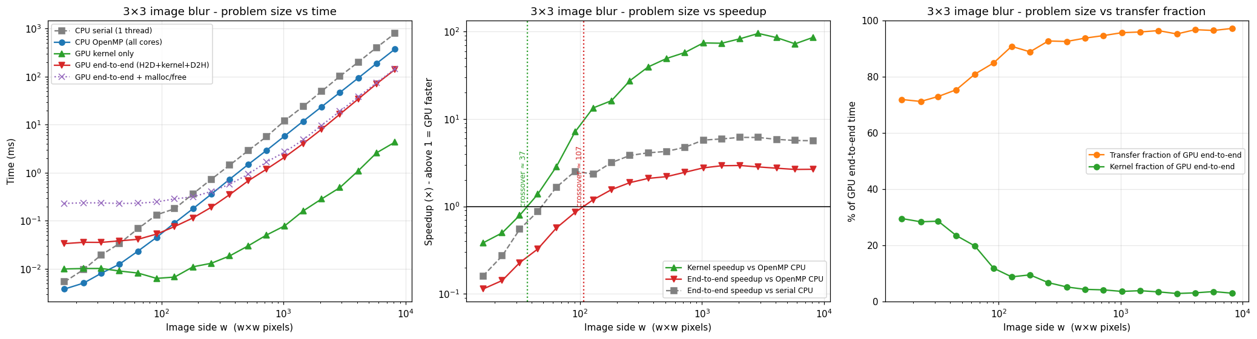
Figure 1. Vector addition: runtime, speedup and transfer fraction across problem size.
Figure 2 shows matrix multiplication crossing over at a smaller size than blur and reaching 24.392× speedup at n=2,048. Its computation grows faster than its input/output volume, allowing kernel work to amortize transfer and launch costs. The graph’s rising end-to-end speedup supports H1.
Inference from the curve. The sharp rise in end-to-end speedup as matrix dimension grows is consistent with computation increasing faster than the amount of input/output data. The measured first persistent win at n=91 is the safer operational threshold than the interpolated n≈70 estimate, because n≈70 lies between sampled points. At n=2,048, 24.392× speedup indicates that the computation is large enough to amortize offload overhead for this implementation.
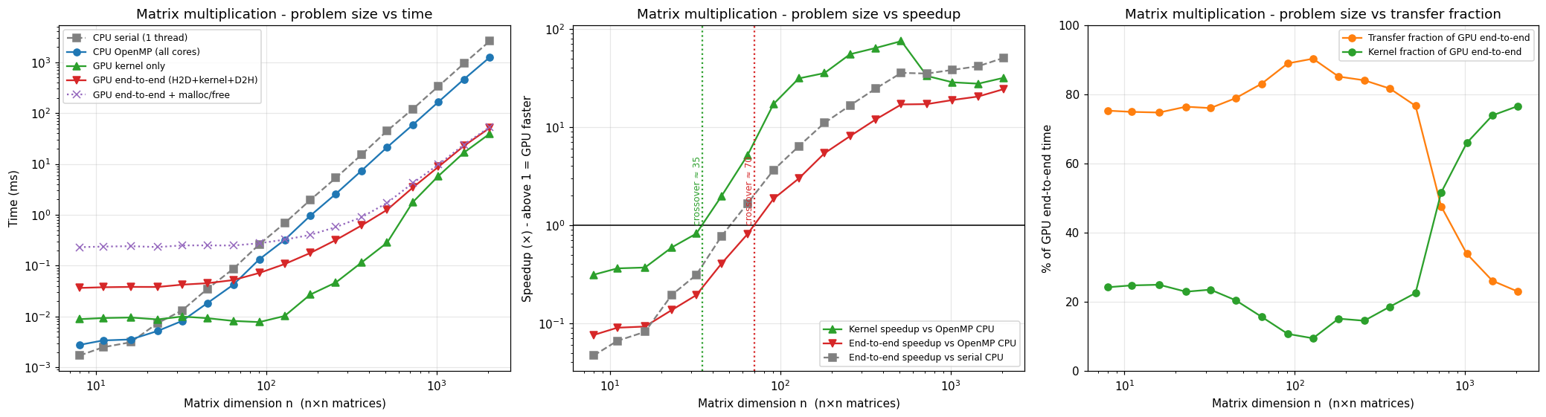
Figure 2. Matrix multiplication: runtime, speedup and transfer fraction across matrix dimension.
Figure 3 shows blur’s kernel crossover near width 37 but end-to-end crossover only near width 107 (first persistent win at 128). The gap is the cost of offloading. Transfer time remains a substantial share of total runtime even after the GPU becomes faster, supporting H2.
Inference from the curve. Blur is less compute-intensive than matrix multiplication, so its end-to-end advantage appears later even though the kernel itself becomes faster at a small width. The difference between the interpolated kernel crossover (≈37 px) and end-to-end crossover (≈107 px) illustrates why kernel timing alone is an unreliable dispatch rule. For workloads near the crossover, the CPU may still be preferable because small timing fluctuations can change which device wins.
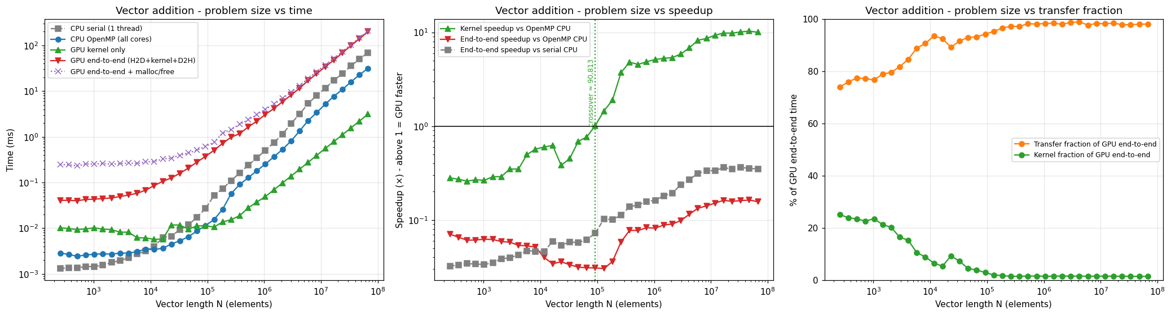
Figure 3. Image blur: runtime, speedup and transfer fraction across image width.
Cross-graph inference. Across the three plots, kernel-only speedup consistently gives a more optimistic picture than end-to-end speedup. Matrix multiplication crosses over earliest because it performs the most work per transferred byte; blur crosses later; vector addition never crosses over. Thus, the crossover is not a property of the GPU alone—it depends on workload arithmetic intensity and the cost of moving data. The timing-decomposition graph reinforces this interpretation by showing that transfers and allocation are meaningful components of total GPU time.
Table 3. Graphs and the inference each supports.
Graph / metric | Where shown | Inference to report
Problem size vs time | Figure 1–3, left/time panels | Shows absolute runtimes and where the GPU end-to-end curve crosses CPU OpenMP.
Speedup vs size | Figure 1–3, speedup panels; Figure 4 | Shows that matrix multiplication gains most, blur gains later, and vector addition remains below 1× end-to-end.
Transfer fraction / timing decomposition | Figure 1–3 transfer panels; Figure 5 | Shows data movement and allocation are important costs, especially for vector addition and smaller workloads.
Effective transfer bandwidth | Figure 6 | Bandwidth rises with transfer size before flattening, suggesting small transfers are more latency-dominated.

The comparison also illustrates the difference between an algorithmic result and an implementation result. A kernel may have a large speedup in isolation, yet the application can remain slower after transfer and launch costs are included. For this reason, the end-to-end curve is the decision-relevant result, while kernel time and transfer fraction help explain why it behaves that way.

5. Correctness and Interpretation
Workload | Maximum relative error | Median end-to-end run-to-run spread
Vector addition | 0 | 5.4%
Matrix multiplication | 3.155 × 10⁻⁷ | 4.6%
Image blur | 0 | 3.5%

The maximum relative error is 0 for vector addition and blur and 3.155×10⁻⁷ for matrix multiplication, so the implementations agree closely at the tested precision. The median end-to-end run-to-run spread is 3.5%–5.4%; this is small enough to show stable overall trends, but it cautions against treating a single near-crossover measurement as a universal boundary. H1 is supported by the different workload crossovers; H2 is supported by the earlier kernel-only than end-to-end crossovers for matrix multiplication and blur; H3 is supported because vector addition never achieves end-to-end speedup above 1.

6. Limitations and Conclusion
Threats to validity include shared-cloud variability, a single GPU and CPU configuration, only three sweep trials, and implementation differences between the CPU and GPU kernels. The GPU used pageable host memory; pinned memory, asynchronous streams and transfer/computation overlap were not evaluated. The interpolated crossover is an estimate, while the first persistent measured win is more directly reproducible. These limitations mean the reported thresholds should be treated as empirical results for this setup, not universal cut-offs.
The study improves internal comparability by using the same workload definitions, data precision and recorded environment across the tested sizes. However, external validity is limited: results may change with different hardware, compiler versions, memory policies, optimized libraries or workloads with irregular access patterns. A follow-up study should vary one factor at a time (for example, memory type or stream count) and repeat the full sweep to isolate its effect.
The results also suggest a simple dispatch policy for this particular setup: keep standalone vector addition on the CPU; consider GPU offloading for matrix multiplication from the first persistent measured win (n=91) and for blur from width 128, then validate thresholds on the target machine. These are empirical thresholds for this benchmark, not general CUDA rules.
There is no single GPU crossover point for all workloads. In these measurements, matrix multiplication benefits most from offloading (up to 24.392×), blur benefits after a later threshold (up to 2.940×), and vector addition remains slower end-to-end (maximum speedup 0.163×). The central inference is that device selection should be based on end-to-end runtime and workload characteristics, not kernel speedup alone. Future experiments should test pinned memory and asynchronous streams, reuse GPU-resident data across kernels, compare tuned CPU/GPU libraries, and repeat the sweep on additional hardware.

References
[1] NVIDIA, CUDA C++ Best Practices Guide, version 13.0. https://docs.nvidia.com/cuda/archive/13.0.0/cuda-c-best-practices-guide/index.html
[2] S. Mittal and J. S. Vetter, “A Survey of CPU-GPU Heterogeneous Computing Techniques,” ACM Computing Surveys, 47(4), 2015. https://doi.org/10.1145/2788396
[3] B. van Werkhoven et al., “Performance Models for CPU-GPU Data Transfers,” IEEE/ACM CCGrid, 2014. https://doi.org/10.1109/CCGrid.2014.16
[4] J. Gómez-Luna et al., “Performance Models for Asynchronous Data Transfers on Consumer Graphics Processing Units,” Journal of Parallel and Distributed Computing, 72(9), 2012. https://doi.org/10.1016/j.jpdc.2011.07.011
[5] R. Landaverde et al., “An Investigation of Unified Memory Access Performance in CUDA,” IEEE HPEC, 2014. https://doi.org/10.1109/HPEC.2014.7040988
[6] A. Geiß et al., “Validating the Performance of GPU Ports Using Differential Performance Models,” Future Generation Computer Systems, 174, 2026. https://doi.org/10.1016/j.future.2025.108018
[7] F. Wang et al., “Accurate and Reliable Energy Measurement and Modelling of Data Transfer Between CPU and GPU,” IEEE Transactions on Computers, 74(3), 2025. https://doi.org/10.1109/TC.2024.3504262

